NAME: GROUP:



Formal Assessment Task 3
ACT | FAT | TO MARKS | SASAMS | ACHIEVEMENT
1 | Listening and Speaking | 25 | 10
2 | Reading & Viewing | 25 | 20
3 | Language Structure | 25 | 40
4 | Writing and Presenting | 25 | 40
 | TOTAL | 100 | 70

FORMAL ASSESSMENT TASK 3
ACTIVITY 1: LISTENING AND SPEAKING
___________________________________________________________________
Date:

Activity
Telephone etiquette: Have a telephone conversation between a customer and a company.

Form of assessment
Oral conversation

Assessment Tool:
Rubric

Recording and Reporting

Criteria | Marks | Learner’s Achievement
Participation in a telephone conversation. | 15
Ability to express self orally | 10
TOTAL | 25

Comment

_________________________________________________________________________________________________________________________________________________________________________________________________________
Rubric to assess listening and speaking: Telephone etiquette
Listening and speaking
25 marks
 | 12-15 | 7-11 | 4-6 | 1-3
Participation in a telephone conversation | Excellent timing, greeting, informative skills.  Excellent telephone etiquette.  Evidence of excellent rehearsal | Good timing, greeting, informative skills.  Good telephone etiquette.  Evidence of good rehearsal | Mediocre timing, greeting, informative skills.  Mediocre telephone etiquette.  Evidence of some rehearsal | Experience many challenges when answering and participating in a telephone conversation. Evidence of no rehearsal
 | 8-10 | 6-7 | 4-5 | 1-3
Ability to express self orally | Expresses her/himself very well. Able to say what he/she wants to say clearly and easily with few or no mistakes. | Expresses him/herself well. Able to say what he/she wants to say clearly and fairly easily, but with some mistakes. | Expresses him/herself with some difficulty. Struggles to say what he/she wants to say and makes many mistakes. | Struggles to express him/herself orally. Makes many mistakes. Difficult to understand. Says only one or two words.

What to do
1. Work in pairs and conduct a telephone conversation between a customer and a manager of a restaurant.
2. Pay attention to the following:
- Answer the telephone quickly.
- Give a welcoming greeting and let the caller know immediately who they are speaking with.

- Help the caller with the proper information.
- Ask the caller if there is anything else that you can help with.
- Thank the caller for calling and wish them a pleasant rest of the day.
- Remember, it’s all about your voice and the way you speak to the customer on the phone.

- Good manners and the tone of your voice are extremely important when it comes to a telephone conversation.
A telephone conversation between a customer and a restaurant manager

Manager : | Good afternoon, Spur Steak Ranch, Pieter talking. How may I help you?
Customer : | Good afternoon sir. This is Mrs Papp speaking. I would like to make a reservation for this evening at six o’clock.
Manager : | Very well madam. For how many people shall I make the reservation?
Customer : | We will be two people.
Manager : | Excellent! We are looking forward to welcome you at six o’clock this evening. Thank you for calling Mrs. Papp and have a pleasant afternoon. Good bye.
Customer : | Thank you, good bye.




FORMAL ASSESSMENT TASK 3
ACTIVITY 2: READING AND VIEWING
___________________________________________________________________
Date:

Activity
Comprehension on communication

Form of assessment
Reading Comprehension

Assessment Tool:
Memorandum

Recording and Reporting
Criteria | Marks | Learner’s Achievement
Reflect on reading material. Answer questions based on communication | 25

Comment

_________________________________________________________________________________________________________________________________________________________________________________________________________

What to do
1. Read the following information text and answer the comprehension questions.

INFORMATION TEXT
WHAT IS COMMUNICATION

Communication is a two way process. When we communicate, we have a sender (the person communicating) and the receiver (the person receiving the information). However, it is as if we talk in code and the receiver has to decode the message before he can understand it.
We respond based on:
- what we think we have heard
- our background and
- our beliefs.

When we communicate, words are only part of the story. We also use body language and tone of voice to communicate.

Tone of voice

Tone of voice is how we say something, compare for example:

- THIS is mine
- This IS mine
- This is MINE

Depending on how we say something, we can change the meaning of our sentence completely. Tone is very important in determining the real message.

Body Language

Body language is the way we use our bodies to communicate, for example rolling our eyes, using our hands and even the way we stand. It is important to keep our body language positive. Some examples of positive body language are:

- Making eye contact
- Keeping our hands open as opposed to clenched
- Smiling
- Standing up straight
- Leaning towards the person we are listening to
- Turning our head slightly towards the person talking.



1. Fill in the correct word. Choose from the word box. (10)

think respond decode two way process background information

person code receiver sender

Communication is a _____________________________________________.

There is a __________________(the person sending the _____________________)

and a _________________ (the ______________ receiving the information).

It is as if we talk in _______________ and the receiver has to _______________ the

message before he can understand it.

We ______________________ based on what we ____________________

we have heard, our beliefs and our __________________________.

2. When we communicate we use the following: (3)

_____________________________________________________________

_____________________________________________________________

_____________________________________________________________

3. Name 6 signs of positive body language. (6)

______________________________________________________________

______________________________________________________________

______________________________________________________________

______________________________________________________________

______________________________________________________________

______________________________________________________________

4. Circle the correct word in brackets.
4.1 Tone of voice is how we (do / say) something. (1)
4.2 Tone is very important in determining the (real / fake) message. (1)
4.3 It is important to keep our body language (negative / positive) (1)
4.4 “Rolling our eyes” is an example of (tone / body language). (1)
4.5 Clenched hands are a sign of (negative / positive) communication. (1)
4.6 Communication is a (one / two) way process. (1)

TOTAL: (25)

FORMAL ASSESSMENT TASK 3
ACTIVITY 3: LANGUAGE STRUCTURES AND CONVENTIONS
___________________________________________________________________
Date:

Activity
Answer language questions

Form of assessment
Written presentation.

Assessment Tool:
Memorandum

Recording and Reporting

Criteria | Marks | Learner’s Achievement
Answer language questions | 25

Comment

_________________________________________________________________________________________________________________________________________________________________________________________________________

What to do.
Answer the Language questions.

QUESTION 1

Decide whether the sentence refers to a specific object and then fill in the correct article. Use either the, a or an to complete the sentences.
1. _________ Children’s Discovery book belongs to my brother. (1)
2. I live in ___________ only green house in First Street. (1)
3. Do you have _______ pen for me? (1)
4. Do you have _________ ruler? (1)
5. Earth is _________ planet. (1)
6. I want __________ ice cream. (1)
7. May I have _________ apple? (1)
8. ____________ new boy was late for school. (1)
9. Janet Smith is __________ artist. (1)
10. ___________ Smiths are my neighbours. (1)

QUESTION 2
Fill in the correct demonstrative pronouns.
REMEMBER
Where? | Singular | Plural
Near | this | these
Far | that | those

1 |  | is my book. | 1
2 |  | are my books. | 1
3 |  | is my car in the car park across the road. | 1
4 |  | are cargo ships in the sea. | 1
5 |  | are my new shoes. | 1

QUESTION 3
Conjunctions are joining words to connect or join phrases or sentences.
Join the sentences by using either because or but. Write the sentences on the lines below.

1 | I could not go to the concert. | but  because | I did not have a pen.
2 | I wanted to play rugby. | but  because | I failed it.
3 | My teacher was angry with me. | but  because | It was vicious.
4 | The test was easy. | but  because | I was sick.
5 | The dog looked friendly. | but  because | I left my boots at home.

1. ____________________________________________________________________________________________________________________________________(2)
2. ____________________________________________________________________________________________________________________________________(2)
3. ____________________________________________________________________________________________________________________________________(2)
4. ____________________________________________________________________________________________________________________________________(2)
5. ____________________________________________________________________________________________________________________________________(2)

TOTAL: (25)

FORMAL ASSESSMENT TASK 3
ACTIVITY 4: WRITING AND PRESENTING
___________________________________________________________________
Date:

Activity
Communication styles

Form of assessment
Written presentation

Assessment Tool:
Memorandum & Rubric

Recording and Reporting
 | Marks | Achieved
Question 1 | 3
Question 2 | 7
Question 3 | 6
Question 4 | 4
Question 5 | 5
TOTAL | 25

Comment

_________________________________________________________________________________________________________________________________________________________________________________________________________

QUESTION 1
Identify the three styles of communication and label the picture (3)
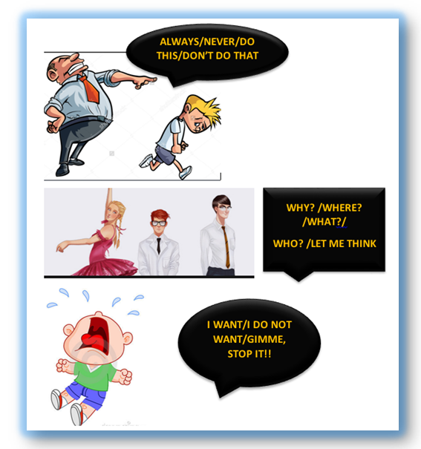

.

QUESTION 2
Write the ego state for each of the following statements. (7)
Only write C / A / P. (It represents: Child, Adult and Parent).

1 | “A client is expecting the delivery this afternoon at 15:00. Can you please make sure it is done?”
2 | “Ah shame, are you not feeling good today?”
3 | “Can we discuss this?”
4 | “You always expect me to work late!”
5 | “How many times have I told you not to be late?”
6 | “I am unable to help you when you are interrupting me.”
7 | “You look tired, why do you not sit down?”

QUESTION 3 (6)
Read the following cartoons and say if the situations are Assertive / Non-Assertive or Aggressive.
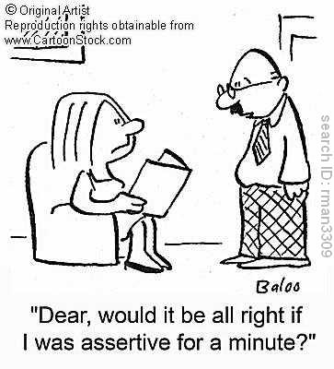
The husband is
__________________________
because he asks his wife’s permission to be assertive.

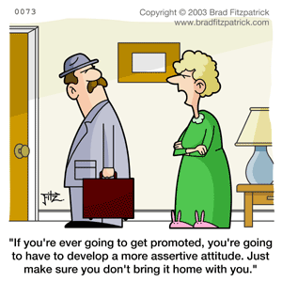
The wife is _________________________
because she gives her husband an order which clearly states that he is not OK.

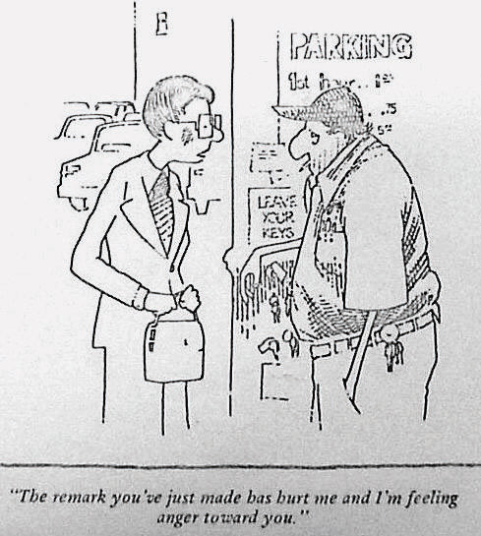
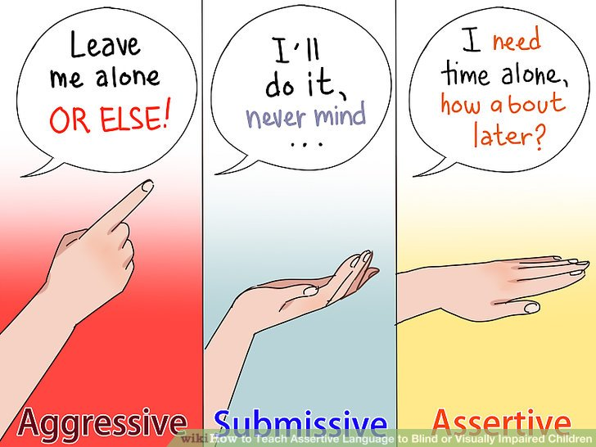
The woman is
___________________________
because she expresses what she thinks and feel in a positive way.
The remark you’ve just made has hurt me and I’m feeling anger toward you.

QUESTION 4 (4)
How do you use Honest, Open, Appropriate and Direct communication to give your message correctly?
Match the non-appropriate message to the appropriate message.

“You always interrupt!”
(aggressive / parent)
“He makes me so mad.”
(non-assertive / child)
2
1
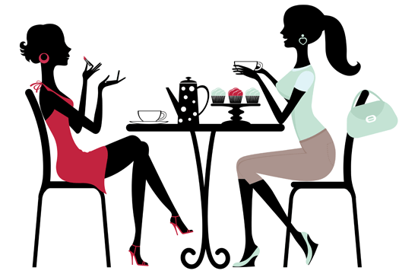
“Would you mind taking this to John?”
(non-assertive / child)

3
“This is sloppy work.”
(aggressive / parent)
4

 | Appropriate message | Number
4.1 | “Please take this to John.”
4.2 | “I would like to speak without interruption.”
4.3 | “The punctuation in your report needs work.”
4.4 | “I get mad when he breaks his promises.”





QUESTION 5
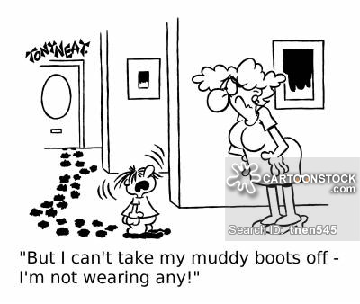
Refer to the cartoon and in one paragraph explain the three states (5) of communication.
Hey , you with the dirty feet, outside!

It’s not my fault.

I have just washed the floor and your feet are dirty. Please go outside and clean them before you come in.

__________________________________________________________________________________________________________________________________________________________________________________________________________________________________________________________________________________________________________________________________________________________________________________________________________________________________________________________________________________________________________________________________________________________________________________________________________________________________________________________________________________________________________________________________________________________________________________________________________________________________________________________________________________________________________________________________________________________________________
Criteria |  | Marks | Achieved
Content | Names the three states of communication and gives an example from the cartoon. | 3
Language | Language and punctuation effectively used. | 1
Structure | Sentences and paragraph well constructed. | 1
TOTAL |  | 5

TOTAL: (25)

